**Project Title:** Advanced Transport (Bus) Monitoring System

**Target Problem:**

When we avail the bus facilities of city we are living in, we face some major problems. Some problems are faced by the passengers and some are faced by the conductor/drivers.

**Problems faced by passengers:**

1. When we wait for buses at the bus-stops, many a times we have to depend on our luck whether we will be getting the direct bus to our destination or we have to break our journey in the middle for bus change.
2. We mostly try to get the buses which will reach us to our destination with shortest time or of any particular speed of a bus as per our preference. But we don’t know when the buses of our preference will come at the stop, so we take the bus which comes at the stop at first or else we have to wait for hours to get our preferred bus, if it comes, at all.

**Problems faced by drivers/conductors:**

1. Racing and rash driving of buses normally occurs due to arrival of a bus of same route as of the previous bus, hence to get most passengers, they tend to go ahead of the other. In this way, accident occurs. Another reason of this problem is also due to driving the bus at low speed to take up as much passengers as they can, in this way, latter buses of same route approaches.

**Solution:**

My solution to this problem is an android app. We all know that android phones are cost effective and hence it is reaching out to every hands of the society in today’s world. So I am using that smartphone to have an app which will be having two types of user 1> driver/conductor/bus depo authority, 2>Passenger. Type 1 will have its access to users with required rights only for the corresponding ranks and not to any passenger. But type 2 is open to all.

Type 1: Their respective routes will be saved in their app by them for one time just after the installation of the app. Then constantly GPS data of the phone, driver & bus information saved at the time of installation will be constantly sent to a server which can be accessed by their corresponding bus depo authority, others buses of the same route & passengers.

Type 2: Passengers will set their destination, and matching buses approaching will be listed with their bus numbers, route numbers, and average speed and how far is it from the passenger. During searching, only once the GPS data of the passenger’s phone will be sent to server so as to perform the backend calculations of finding desired buses for the passenger.

In type 1 app, each phone will constantly show if there is a nearby bus approaching of the same route, so as they can control their speeds beforehand only.

In type 2 app, the passengers will get listing of nearby all buses of desired route approaching, so they can understand how long they have to wait for the bus of their preference to come and decide accordingly.

Type of problem solved: in this project, we can give a fabulous transport (bus) monitoring system app to the society. Which doesn’t involve any extra cost other than their own smartphone which is they are already having.

**Algorithm:**

1. We will keep the tracks of routes, bus numbers, their average speed, current location & up/down direction of the bus route currently covering by the bus.
2. Whenever a passenger searches, nearby of matching route’s bus information will be sent to the type 2 user.
3. In type 1 user mode, buses are only listed with matching routes.

Along with bus listings, there will be an option for map view using Google map API. Whatever listings are shown will be shown on map.

**Block diagram:**

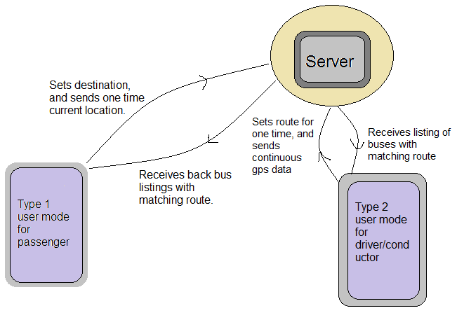

**Project Submitted by:**

Abhishek Sarkar

BTECH/ECE/2013/032

4th year ECE, MCKV Institute of Engineering

Email id: [abhisheksarkar30@gmail.com](mailto:abhisheksarkar30@gmail.com)

Ph no.: 8981871941